Emily Cole and Oyinade Oyenusi
January 15, 2015
Abstract
Short term memory is a part of the brain that is used for storing and managing information that is necessary to carry out cognitive tasks such as learning, reading, and comprehension for a temporary period of time. Distractors have been found to negatively impact short term memory. Our study investigates how the memorization of animals are affected by sounds that to do not belong to that animal. We completed our study looking at two scenarios, both including pictures of animals, where there was one with sound and one without sound. We concluded that short term memory is not negatively influence by sound. When comparing the scenarios where sound was and was not incorporated, it was found that the scenario with sound generally increased the average number of animals memorized correctly.
Introduction
Short term memory is defined as the ability to remember or process information in a matter of seconds. We are studying if auditory distractions have an impact on short term memory. We came upon this topic of investigation because *we believe that when people listen to voices or sounds it distracts them. For example, when a student is doing their reading homework and listening to a dog’s bark or a conversation, they tend focus more on the sound than the task at hand. So, we hypothesized that there would be a small chance that the person being tested would remember what they had previously seen. Through our research we came upon these three databases which helped us understand our experiment in its entirety. In the article, “Short Term Memory’s Effectiveness Influenced by Sight, Sound” by the University of Rochester it explained that it’s not what you hear specifically, but how you hear it. For example, one study was done in the 1960’s and tested people that spoke many different languages. The people whose languages have characters remember the figures shown much better opposed to those whose languages don’t. The average number of images that were remembered was seven. “Neural Correlates of Short-Tern Memory in Primate Auditory Cortex” by US National Library of Medicine mentions that the prefrontal cortex controls the short term memory, and if a task is being performed while trying to concentrate you will not complete the task as effectively opposed to someone who is not multitasking. In “The Effect of Sound Distraction upon Memory” by John J. B. Morgan, there was an experiment conducted where there was a series of words that were required of the person in the experiment to remember. When they remembered it, they would press a key which started a series of reactions after an image was shown. Two out of the four tests were done silently and the other two were done with background sound. The results showed little change between the silent and noisy experiments. The results also depended on the word that was to be remember and the person itself.
Within these three articles, we found more than we were looking for. They explained how the mind has an average capacity to remember up to seven objects shown at a time. In our experiment we tested those limits by showing up to nine images. Something we realized from reading these articles was that hearing someone speak something is much easier to remember than shapes being shown, which explains why it’s easier for people to remember music. In the second article listed, it was explained how multitasking will negatively affect your memory. Stated in the last article is that loud music negatively affects the brain, but not as much as expected. In the experiment performed, it was shown that the short term memory has multiple variables that come into account such as age, what word is being tested, and where someone is being tested. Our research question was: do animal sounds that don’t pertain to the animal effect short term memory? We chose animal sounds because they are familiar sounds that would draw attention away from the pictures being shown, which also happen to be animals. We hypothesized that sound would have a negative impact on the memorization of the animals being shown.
Methods
We tested a total of 31 people, both male and female, ages 12 to 51. There were 29 females and two males tested. Only two males were tested due to the fact that the testing was done primarily at Roland Park Country School where most of the population are females. Some subjects always listened to music during work, some did occasionally, and some didn’t listen to music at all while working, which we found out by asking for the information prior to the test. When the test began, the reader was given an unlimited amount of time to read the instructions. They began the program when they were ready nu pressing the space bar.
Instructions
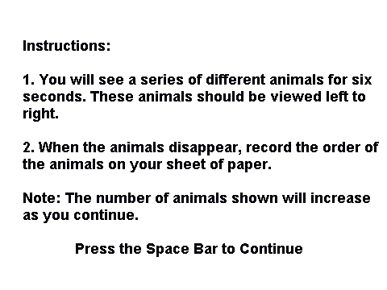
The first test did not have any noises. We started with one animal and increased increments of two until we reached the maximum of nine animals on the slide.
Figure 1: this slide features one animal
:
Figure 2: this slide features three animals
Figure 4: this slide features seven animals
Figure 3: this slide features five animals

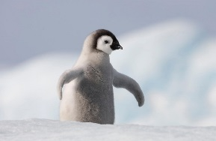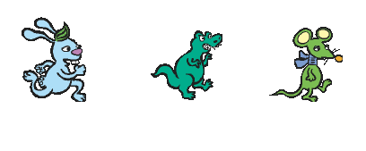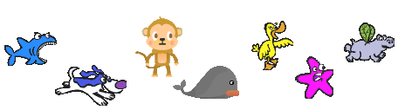
Figure 5: this slide features nine animals

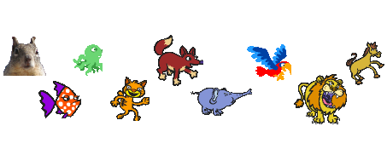
The person tested was given six seconds to try and memorize the animals. After six seconds, the slide was changed automatically. They then had six seconds to write down the animals they remembered after the picture had gone. After the first part of the test was over, the reader had an unlimited amount of time to read the instructions for the second part of the test.
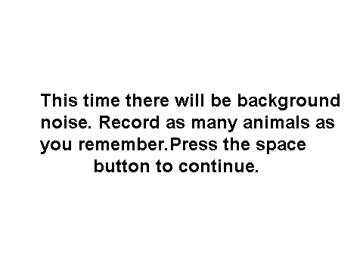
This section was the same as the first section except for the fact that it incorporated a noise aspect. A sound belonging to an animal played in the background. However, the noise of this animal did not belong to any of the animals shown on the screen. For example, the first slide showed a penguin. However, the noise for this slide was a sea lion. After completing the steps that were completed in the first test with the noise, the test had been completed. Then we had to grade the tests. Each section of the test was worth 25 points since there were 25 animals to memorize for each part. Answers that were in the correct order from the beginning of the sequence were counted correct. For example, if the correct response was bunny, dinosaur, mouse and the person being tested said bunny and then mouse, they would get a point for bunny, but they would not get a point for mouse due to the fact that they skipped dinosaur. There were no points taken off if the person being tested wrote down an animal that resembled the animal shown on the screen.
Results
Without sound

Femi Oyenusi | 1/1 | 3/3 | 3/5 | 4/7 | 2/9
Morenike Oyenusi | 1/1 | 3/3 | 3/5 | 4/7 | 3/9
Olamide Oyenusi | 1/1 | 3/3 | 5/5 | 1/7 | 4/9
Emma Radinsky | 1/1 | 3/3 | 2/5 | 2/7 | 2/9
Anna Killingstad | 1/1 | 3/3 | 4/5 | 3/7 | 2/9
Julia Zhan | 1/1 | 2/3 | 0/5 | 5/7 | 1/9
Natalee Huber | 1/1 | 3/3 | 4/5 | 1/7 | 2/9
Olivia Smith | 1/1 | 3/3 | 2/5 | 4/7 | 4/9
Emily Dyer | 1/1 | 3/3 | 3/3 | 2/7 | 4/9
Lilly Ratcliff | 1/1 | 2/3 | 0/5 | 3/7 | 3/9
Raley Young | 1/1 | 3/3 | 2/5 | 4/7 | 3/9
Mary Griffin | 1/1 | 3/3 | 2/5 | 5/7 | 2/9
Gabby Emge | 1/1 | 2/3 | 4/5 | 4/7 | 2/9
Gigi Melchiorre | 1/1 | 2/3 | 1/5 | 0/7 | 0/9
Eleanor Reiner | 1/1 | 3/3 | 5/5 | 2/7 | 2/9
Hailey Freund | 1/1 | 3/3 | 4/5 | 5/7 | 2/9
Mia Clary | 1/1 | 3/3 | 0/5 | 3/7 | 4/9
Adele Spencer | 1/1 | 3/3 | 3/5 | 1/7 | 1/9
Casey Feinstein | 1/1 | 3/3 | 5/5 | 2/7 | 4/9
Liz Salmond | 1/1 | 3/3 | 1/5 | 2/7 | 1/9
Alex Goldstein | 1/1 | 2/3 | 0/5 | 0/7 | 0/9
Jewell Booker | 1/1 | 3/3 | 0/5 | 2/7 | 2/9
Emma Wang | 1/1 | 3/3 | 3/5 | 2/7 | 1/9
Lauryn Norris | 1/1 | 3/3 | 4/5 | 1/7 | 2/9
Amber Bustard | 1/1 | 2/3 | 3/5 | 2/7 | 3/9
Ajée Robinson | 1/1 | 3/3 | 4/5 | 3/7 | 4/9
Rebecca Zipper | 1/1 | 3/3 | 2/5 | 1/7 | 2/9
Erica Dougherty | 1/1 | 3/3 | 5/5 | 2/7 | 3/9
Hannah Rhea | 1/1 | 1/3 | 3/5 | 3/7 | 3/9
Sophia Litrenta | 1/1 | 3/3 | 3/5 | 2/7 | 1/9

With Sound

Name | Slide 1 | Slide 2 | Slide 3 | Slide 4 | Slide 5
- Femi Oyenusi | 1/1 | 3/3 | 5/5 | 2/7 | 4/9
- Morenike Oyenusi | 1/1 | 3/3 | 5/5 | 3/7 | 5/9
- Olamide Oyenusi | 1/1 | 3/3 | 5/5 | 3/7 | 5/9
- Emma Radinsky | 1/1 | 3/3 | 4/5 | 2/7 | 1/9
- Anna Killingstad | 1/1 | 3/3 | 3/5 | 4/7 | 2/9
- Julia Zahn | 1/1 | 3/3 | 3/5 | 2/7 | 0/9
- Natalee Huber | 1/1 | 3/3 | 5/5 | 4/7 | 4/9
- Olivia Smith | 1/1 | 3/3 | 2/5 | 0/7 | 2/9
- Emily Dyer | 1/1 | 2/3 | 5/5 | 4/7 | 2/9
- Lilly Ratcliffe | 1/1 | 3/3 | 2/5 | 3/7 | 1/9
- Raley Young | 1/1 | 3/3 | 4/5 | 4/7 | 4/9
- Mary Griffin | 1/1 | 3/3 | 4/5 | 6/7 | 2/9
- Sophia Litrenta | 1/1 | 3/3 | 5/5 | 3/7 | 3/9
- Hannah Rhea | 1/1 | 3/3 | 5/5 | 0/7 | 1/9
- Gabby Emge | 1/1 | 3/3 | 5/5 | 2/7 | 3/9
- Gigi Melchiorre | 1/1 | 3/3 | 1/5 | 2/7 | 3/9
- Eleanor Reiner | 1/1 | 3/3 | 3/5 | 2/7 | 3/9
- Hailey Freund | 1/1 | 2/3 | 4/5 | 6/7 | 3/9
- Mia Clary | 1/1 | 3/3 | 4/5 | 4/7 | 4/9
- Adele Spencer | 1/1 | 0/3 | 1/5 | 1/7 | 1/9
- Casey Feinstein | 1/1 | 3/3 | 5/5 | 1/7 | 1/9
- Liz Salmond | 1/1 | 3/3 | 2/5 | 0/7 | 1/9
- Alex Goldstein | 1/1 | 3/3 | 5/5 | 1/7 | 0/9
- Ajée Robinson | 1/1 | 3/3 | 5/5 | 4/7 | 4/9
- Jewell Booker | 1/1 | 3/3 | 4/5 | 5/7 | 1/9
- Lauryn Norris | 1/1 | 3/3 | 2/5 | 1/7 | 2/9
- Rebecca Zipper | 1/1 | 3/3 | 5/5 | 3/7 | 0/9
- Erica Dougherty | 1/1 | 3/3 | 5/5 | 1/7 | 3/9
- Amber Bustard | 1/1 | 3/3 | 4/5 | 4/7 | 0/9
- Emma Wang | 1/1 | 3/3 | 5/5 | 5/7 | 3/9
- Robin Prescott | 1/1 | 3/3 | 5/5 | 4/7 | 4/9

1st slide 1
2nd slide: 0.1732
3rd slide: 0.006
4th slide: 0
5th slide: 0

Our data showed that the test with sound had higher results than without the sound. In slide one there was no difference between the two tests because everyone we tested got the animal correct. In slide two the average for our test without sound was 2.77419, and the test with sound was 2.7333 which are both close to three. In slide three, in the test without sound, the average was 2.6333 which is less than the test with sound, and its average was 3.935. The more animals added to the slides the harder it was to remember, so by slide four and five the averages were the lowest compared to the ideal score leaving that data hard to analyze.
Discussion
We came to the conclusion that the animal sounds playing in the background during the second portion of the test generally had a positive effect on the memorization of the animals displayed on the screen. This means that our hypothesis, that the sound would have a negative effect on the memorization of the animals, was incorrect. If you compare both of the graphs, you will see that for the first slide, where one animal was shown, the average number correct for both with sound and without sound was one out of one compared to the ideal target of one. In this first slide, there was no variety in the results for the testing done with sound and without sound. For the next slide, where three animals were shown, the average number correct without sound was about 2.77 and the average number correct with sound was about 2.73 compared to the ideal target of three. This is the only slide in which the average number correct without sound was greater than the average number correct with sound, and there is only a difference of 0.04. In the third slide, where five animals were shown, the average number correct without sound was about 2.63 and the average number correct with sound was about 3.94 compared to the ideal target of five. This time, the average number correct with sound was 1.31 higher than the average number correct without sound. This can be seen as quite a significant difference. In the next slide, where seven animals were shown, the average number correct without sound was about 2.58 and the average number correct with sound was about 2.90 compared to the ideal target of seven. In this slide, while the difference is not as significant as the one in the third slide, it is shown that the average number correct with sound was 0.32 higher than the average number correct without sound. For the fifth and final slide, where nine animals were shown, the average number correct without sound was about 2.35 and the average number correct with sound was about 2.45 compared to the ideal target of nine. While the difference here was also quite minimal, the average number correct with sound was 0.1 higher than the average correct without sound. This proves the general pattern that memory of the animals shown was in fact not negatively influenced by the animal sounds heard in the background.
For further research purposes, it may be beneficial not to show the same animals for both parts of the test. It could be possible that the general increase in the average number correct during the sound portion was due to the fact that the people being tested already had some of the animals memorized since the same animals were shown on each slide in the prior section. If we showed different animals for the sections with and without sound, it would ensure that the average number correct was based solely on what the person being tested was able to memorize in the allotted time.
Bibliography
Alvarez, P., Zola-Morgan, S., & Squire, L. R.. (1994). The Animal Model of Human Amnesia: Long-Term Memory Impaired and Short-Term Memory Intact. Proceedings of the National Academy of Sciences of the United States of America, 91
John J. B. Morgan. (1917). The Effect of Sound Distraction upon Memory. The American Journal of Psychology, 28(2), 191–208.
McLeod, S. (2009). Short Term Memory. Retrieved January 15, 2016, from Simply Psychology website: http://www.simplypsychology.org/short-term-memory.html
Newport, E., & Supalla, T. (2004, August 31). Short Term Memory's Effectiveness Influenced by Sight, Sound. Retrieved January 15, 2016, from University of Rochester website: http://www.rochester.edu/news/show.php?id=1850
Söderlund, G. B., Sikström, S., Loftesnes, J. M., & Sonuga-Barke, E. J. (2010, September 29). The Effects of Background White Noise on Memory Performance in Inattentive School Children. Retrieved January 15, 2016, from National Center for Biotechnology Information website: http://www.ncbi.nlm.nih.gov/pmc/articles/PMC2955636/

